February 14, 2014

**To** Bruce Bolden

**From** Colby Rush

**Subject** Assignment #2

**Introduction**

These are the results of Assignment #2 on my Vaio 1.73 MHz laptop, running Windows 7 version 6.1

**Overview**

The task given was to create a group of functions to familiarize ourselves with basic java drawing and window functions, as well as use these functions to graph some given functions together on a window.

**Summary**

Installation was straightforward; I simple went to Java’s website and picked up the Developer’s Kit of Java SE 7u51, and pressed the big button to install it. There was a problem at first where javac wasn’t recognized by the command line, but I discovered my PATH variables were not correct to locate javac.exe. I changed that, and then everything worked fine.

**Appendices**

All that was accomplished was the creation of most of the functions asked for, as well as a 500x500 window containing the graphed functions.

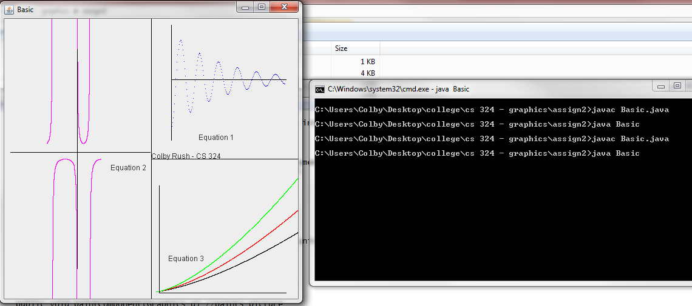Here’s a picture for proof:

Programmer’s log, containing my thought process as the assignment went on, can be found attached to this memo, along with source code. Source code can also be found at github.com/colbyrush